CENWP-OD-B 22 May 2023

MEMORANDUM FOR THE RECORD

SUBJECT: 22BON023 MFR AFF Salmonid Mortality

On 22 May, Columbia River Inter-Tribal Fish Commission (CRITFC) Biologists notified Bonneville Project Biologists of one salmonid mortality found on the valve 15 trash rack in the Adult Fish Facility (AFF). The fish was scanned for PIT tags, inspected, and returned to the river.

- Species – Salmonid Spp.
- Origin – Unknown
- Length – 47.9 cm
- Marks and tags – None
- Marks and Injuries found on carcass – None
- Cause and Time of Death – Unknown
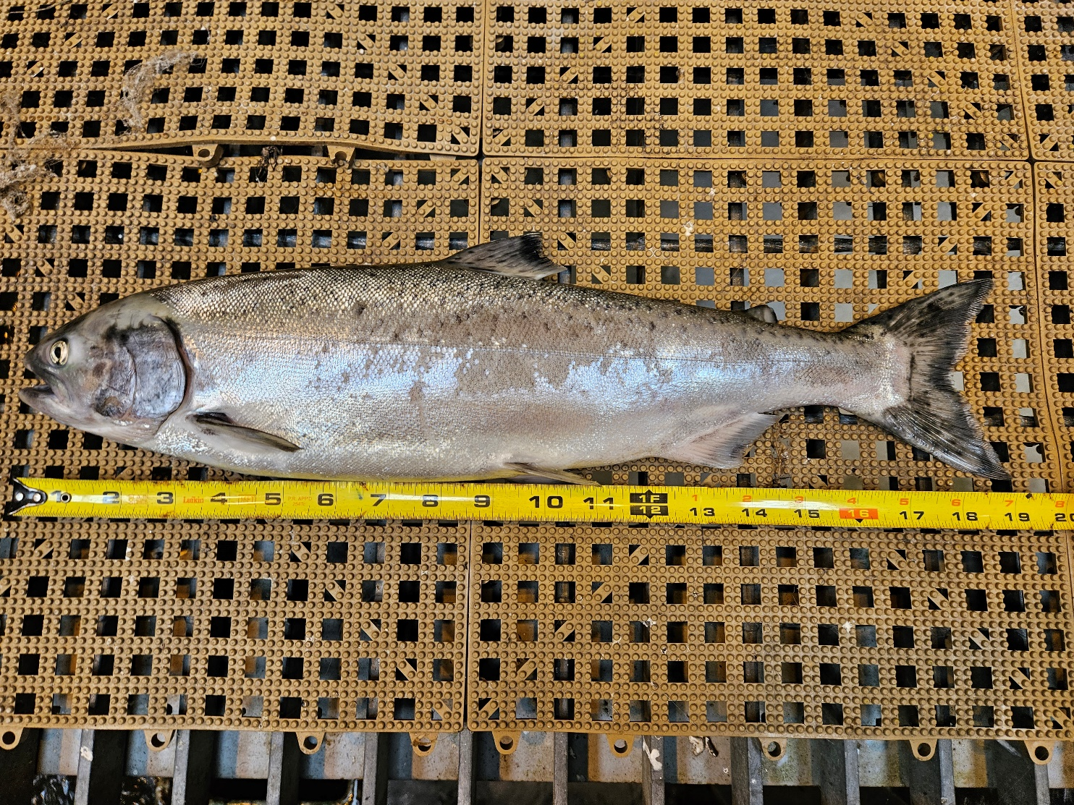
- Future and Preventative Measures – None

Sincerely,
Bonneville Project Fisheries

